**CENWP-OD-B 10 July 2024**

**MEMORANDUM FOR THE RECORD**

**SUBJECT: 24BON023 MFR WA Shore AWS RB1 Pacific Lamprey Mortality**

On the morning of 10 July 2024, Project Biologists discovered one adult Pacific Lamprey mortality in Rest Box 1 of the Washington Shore Auxiliary Water Supply LPS (WA Shore AWS LPS RB1). The fish was measured, scanned for PIT tags, inspected, and returned to the river.

1. Species – Pacific Lamprey (*Entosphenus tridentatus*)
2. Origin – Unknown
3. Length – 70.5 cm
4. Marks and tags – None
5. Marks and Injuries found on carcass – None.
6. Cause and Time of Death – Unknown
7. Future and Preventative Measures – N/A

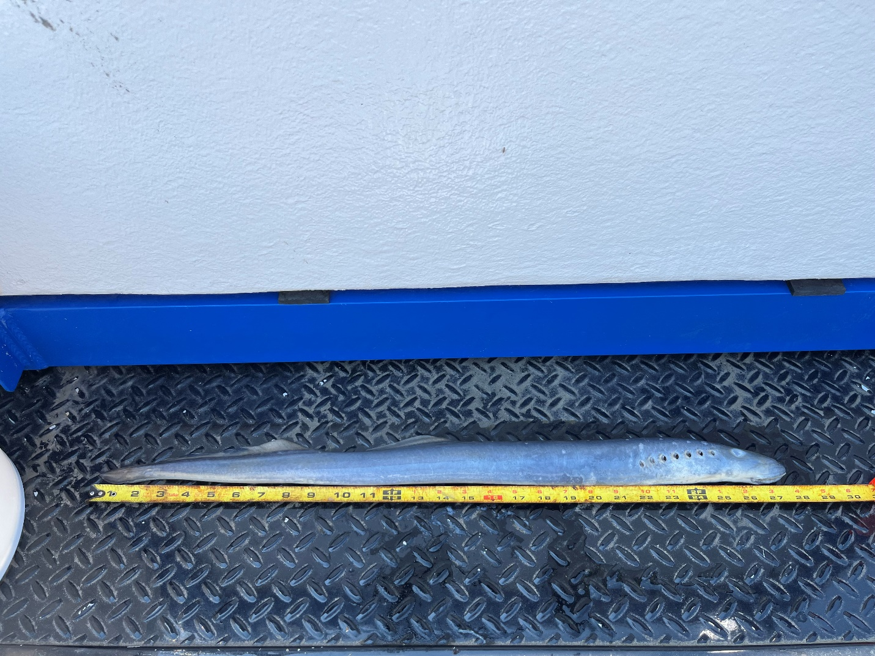

Sincerely,

Bonneville Project Fisheries